### **Final Submission Phase**

|  |  |
| --- | --- |
| Name | JAGATHEESH B |
| NM Id | 912D6C8E79E54D694A04C468ED615272 |
| Project Name | Creating an Email Campaign in MailChimp |

### **Empathize & Discover:**

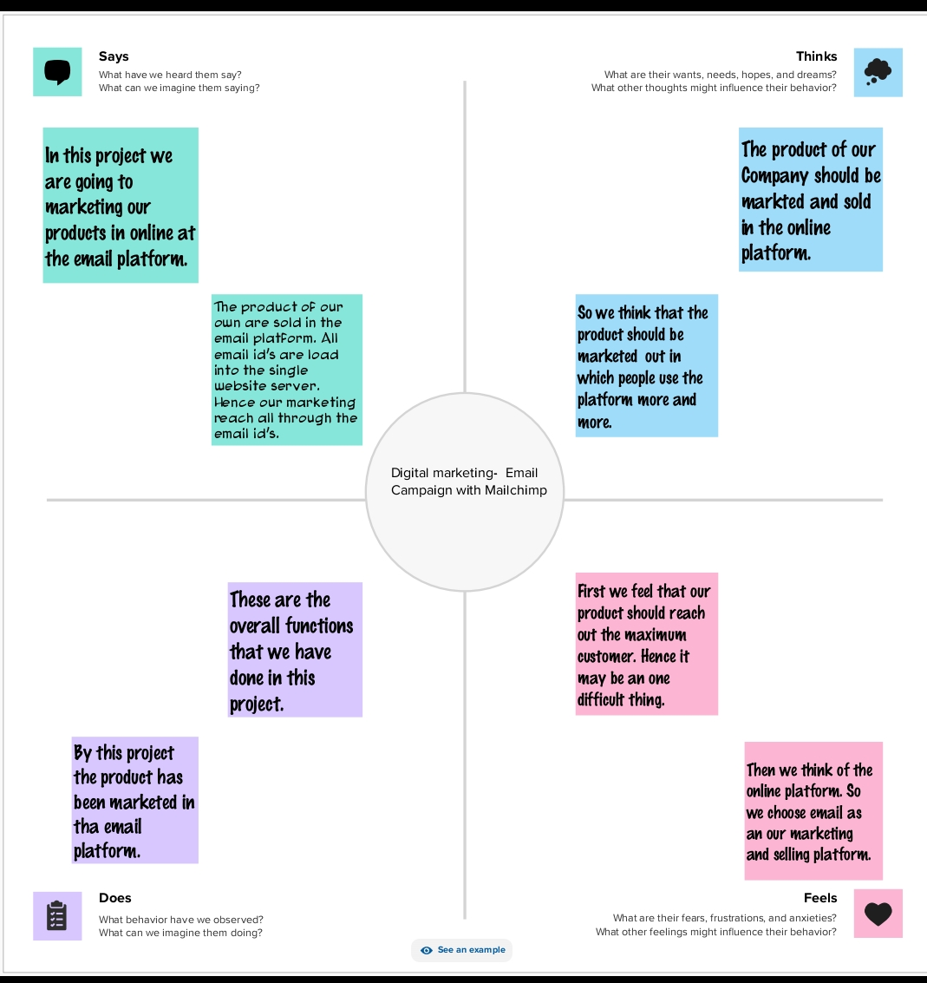

**Brainstorm & Prioritize Ideas:**

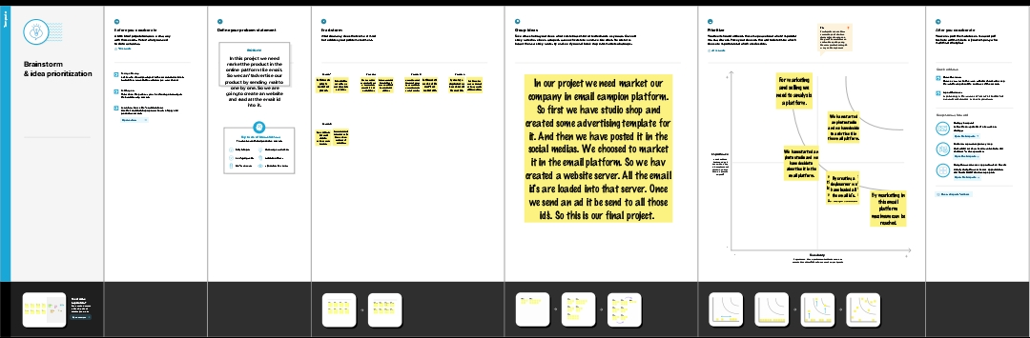

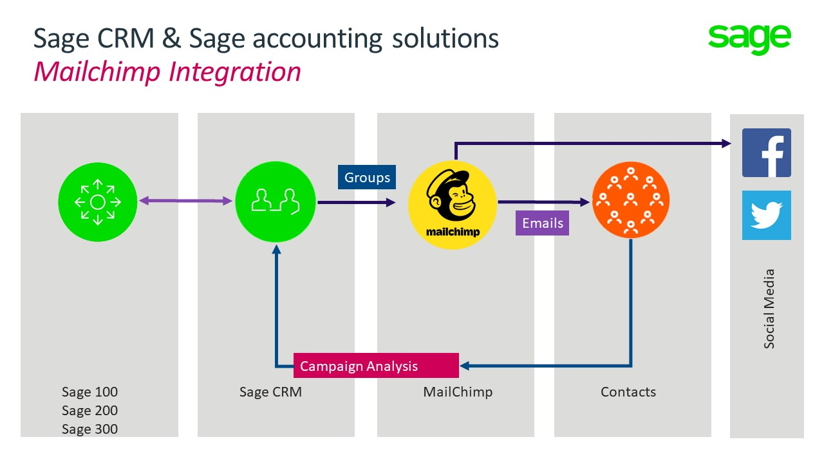**Solution Architecture:**

### **Customer Journey Maps:**

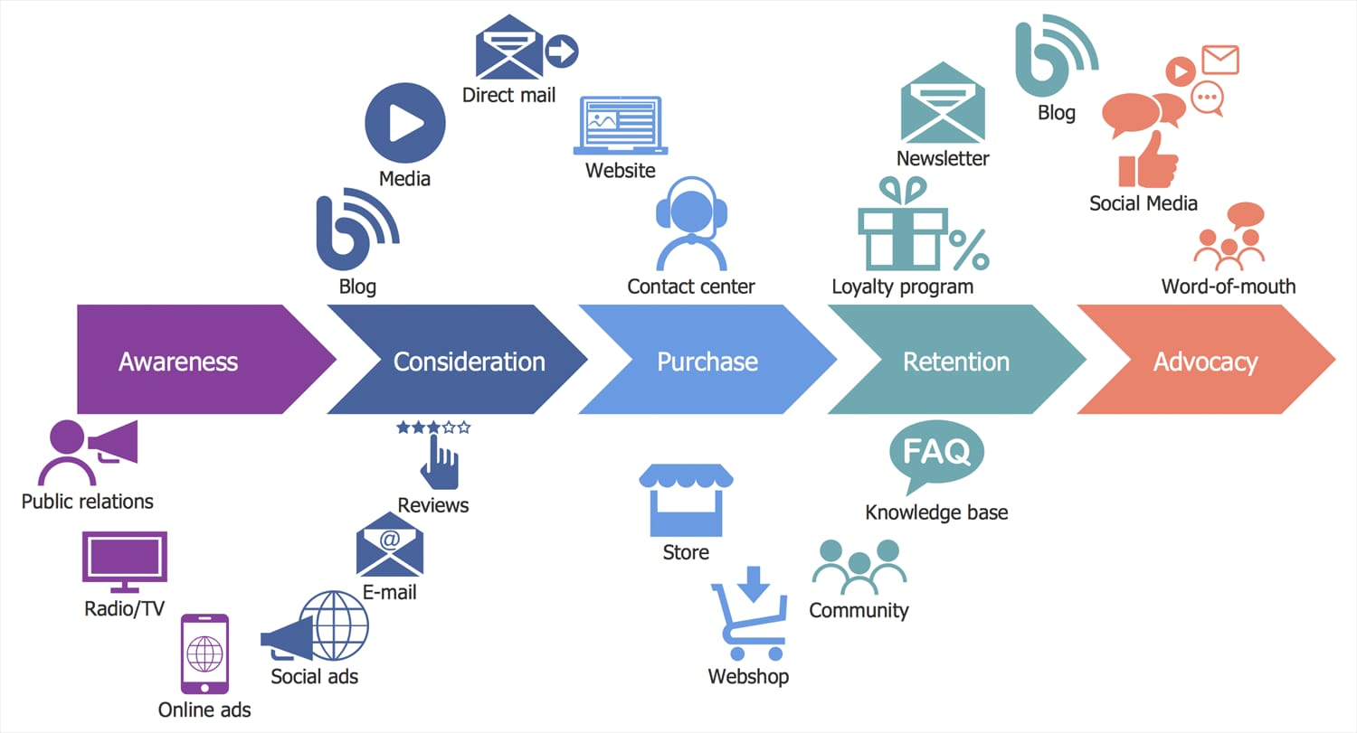

### **Technical Architecture:**

### 

### **Project Demonstration:**

